Software Requirements Specification (SRS)

Himanshu Kumar
UID: 24BCS12643

KeyForge – User‑Defined Encryption Key Manager

1. Introduction
This Software Requirements Specification (SRS) document describes the complete functional and non‑functional requirements of the KeyForge system. KeyForge is a full‑stack security application developed using the Spring Boot framework that enables users to manage cryptographic keys and securely encrypt/decrypt messages.

1.1 Purpose
The purpose of this document is to provide a detailed description of the KeyForge system for developers, project evaluators, and stakeholders, following the IEEE‑830 / IEEE‑29148 SRS standard.

1.2 Scope
KeyForge provides secure user authentication, user‑controlled cryptographic key storage, message encryption, decryption, auditing, and secure API access.

1.3 Definitions, Acronyms, Abbreviations
AES – Advanced Encryption Standard
RSA – Rivest‑Shamir‑Adleman
JWT – JSON Web Token
RBAC – Role‑Based Access Control

2. Overall Description

2.1 Product Perspective
KeyForge is a standalone web application that follows a layered architecture with frontend, backend, security, and persistence layers.
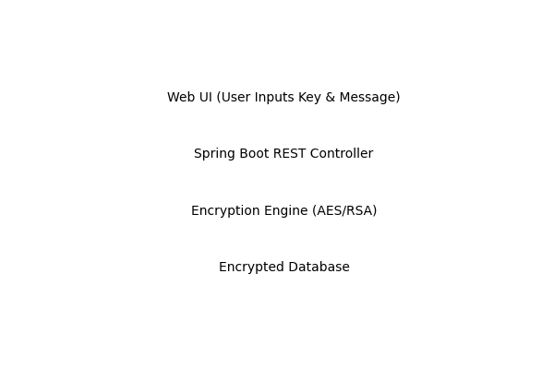

2.2 User Classes and Characteristics
• Normal Users – Encrypt/decrypt messages and manage keys
• Admin Users – Monitor logs and system security

2.3 Operating Environment
Client: Web Browser
Server: Java Spring Boot
Database: MySQL / PostgreSQL
OS: Windows / Linux

3. System Features

3.1 User Authentication Module
Users can register and log in using secure credentials. Passwords are hashed using BCrypt.

3.2 Cryptographic Key Input & Management
Users can manually input their own cryptographic keys or generate new ones. Keys are encrypted before storage.

3.3 Message Encryption
Users select a key and encrypt plaintext messages securely.

3.4 Message Decryption
Only authorized users can decrypt encrypted messages.

3.5 Audit Logging
Tracks user activity such as login attempts and encryption events.

User Interface Illustration
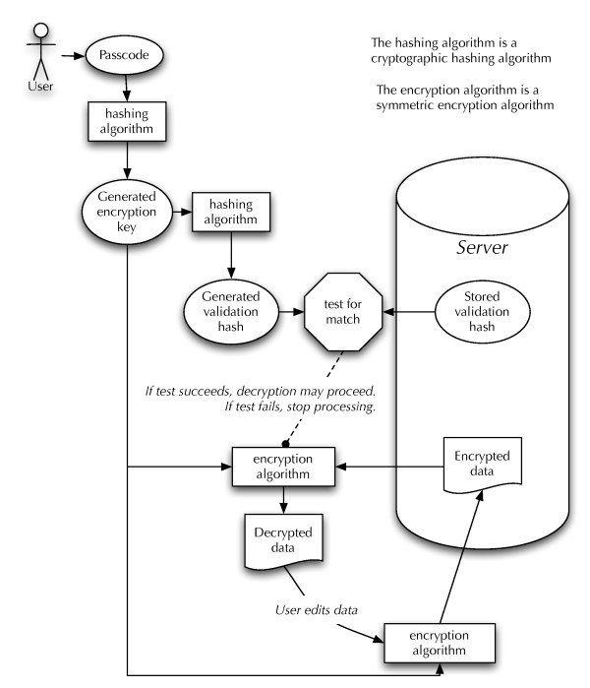
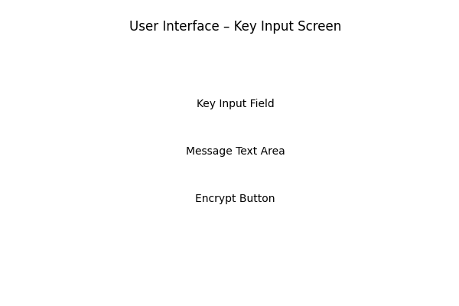

4. External Interface Requirements

4.1 User Interfaces
The system provides a responsive web interface allowing users to input cryptographic keys, enter messages, and view encrypted output.

4.2 Hardware Interfaces
No special hardware is required.

4.3 Software Interfaces
Spring Security, JPA/Hibernate, JWT libraries, and cryptographic providers.

5. Database Design
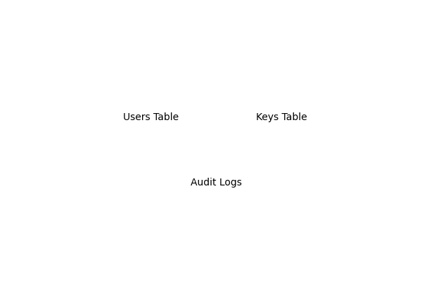
The database stores encrypted user credentials, encrypted cryptographic keys, and audit logs.

6. Non‑Functional Requirements
• Security: Strong encryption and access control
• Performance: Encryption within milliseconds
• Scalability: Supports thousands of users
• Reliability: Data integrity and fault tolerance

7. Security Workflow Diagram
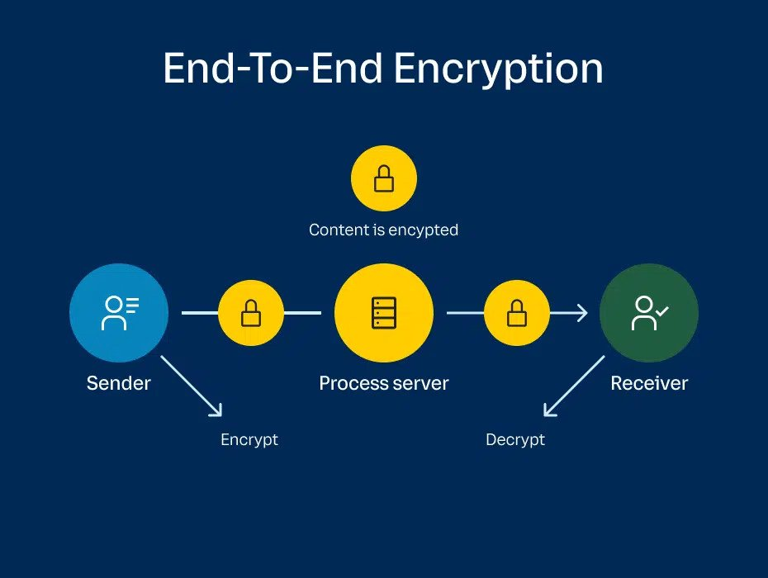
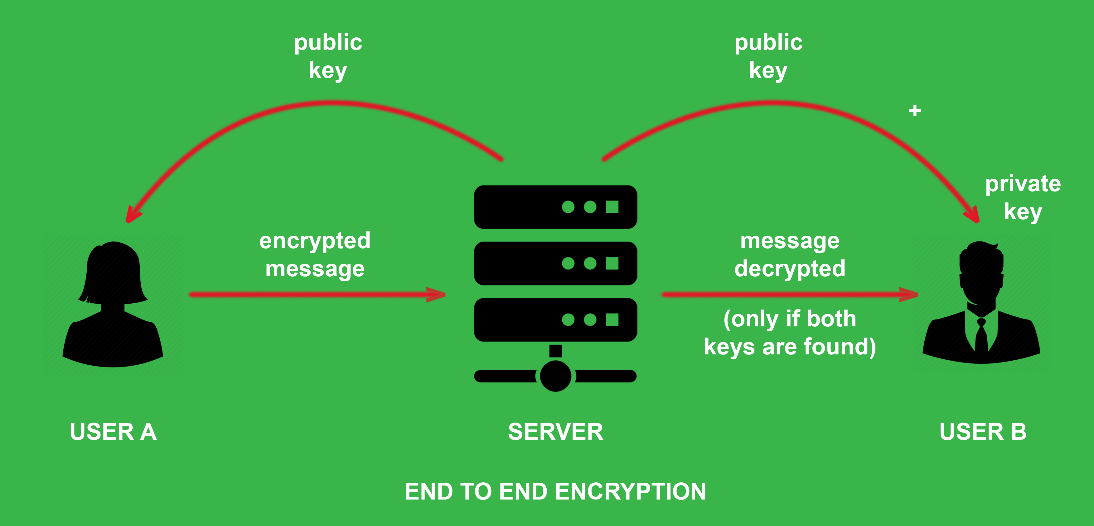
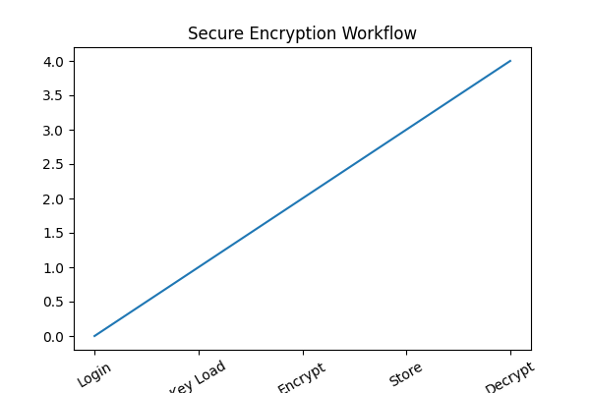

Module 1: User Authentication & Authorization
Handles user registration, login, password hashing (BCrypt), and JWT-based session management.

Module 2: User Profile Management
Allows users to manage credentials, reset passwords, and configure security preferences.

Module 3: Cryptographic Key Generation
Users can generate AES, RSA, or ECC keys. Private keys are encrypted using user passwords.

Module 4: Secure Key Storage
Keys are stored encrypted in the database using a master key and user-specific salts.

Module 5: Message Encryption Engine
Uses user-selected keys to encrypt messages before transmission.

Module 6: Message Decryption Engine
Only authorized users with valid keys can decrypt received messages.

Module 7: Audit Logs & Monitoring
Tracks login attempts, key usage, and encryption events for compliance.

Module 8: API & Integration Layer
Provides REST APIs for external apps to use KeyForge encryption services.

8. Conclusion
KeyForge ensures user‑centric encryption and secure communication through a modular, scalable, and standards‑compliant design.

